- Purpose
  - The purpose of this document is to describe the procedure for packaging a propane burnisher.
- Scope
  - This SOP applies to all equipment assembly team members. The process applies to the following machines:
E012800EQM0600BE1200 – 21” Optima XR
E012805EQM0600BE1200 – 21” Optima XR w/ Clutch
E012815EQM0600BE1200 – 21” Optima XR w/ Emissions & Clutch
E012830EQM0600BE1200 – 27” Optima XR
E012835EQM0600BE1200 – 27” Optima XR w/ Clutch
E012840EQM0600BE1200 – 27” Optima XR w/ Emissions
E012850EQM0600BE1200 – 27” Optima XR w/ Dust Control
E012860EQM0600BE1200 – 27” Optima XR w/ Clutch & Dust Control
E012865EQM0600BE1200 – 27” Optima XR w/ Emissions & Dust Control
E012875EQM0600BE1200 – 27” Optima XR w/ Emissions, Clutch, & Dust Control
- Responsibilities
  - The operations manager/supervisor is responsible for enforcing this SOP.
- Materials
  - The proper materials needed for this process are listed on the sub-assembly work order.
  - Hand/Power Tools
- Definitions

- Procedure
  - Place the assembled and tested propane burnisher onto a pallet (12697).

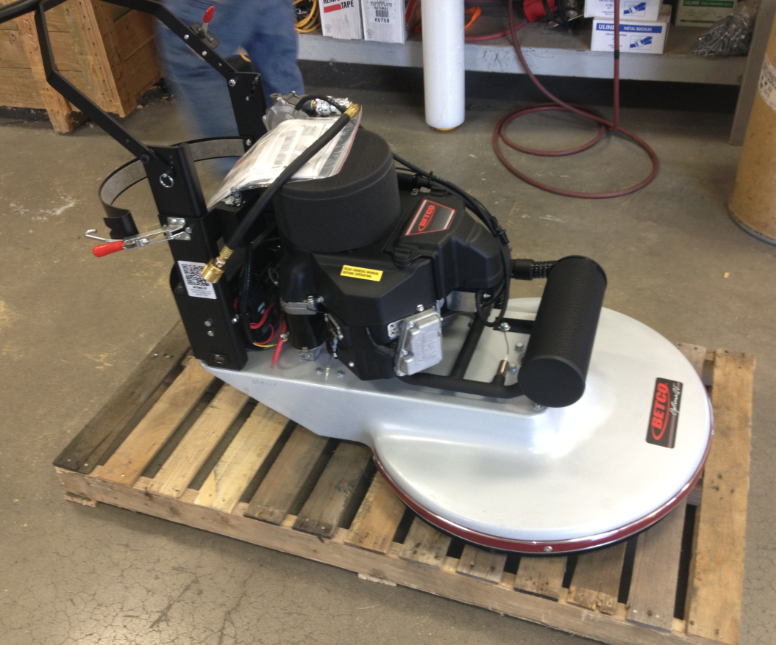
  - Remove the pins from the handle and rotate it to the transport position as shown. Replace the pins into the locations shown to secure the handle.

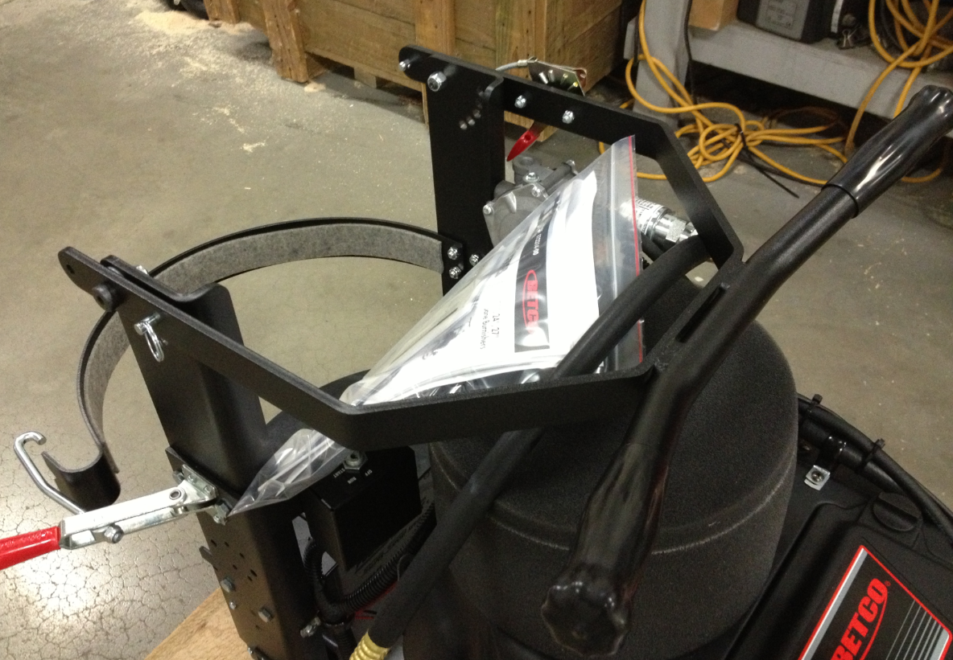

  - Place 2 of the 2x4 pieces under each side of the machine in the locations shown. These help take some of the weight off of the wheels. Fasten them to the pallet using wood screws (88001).

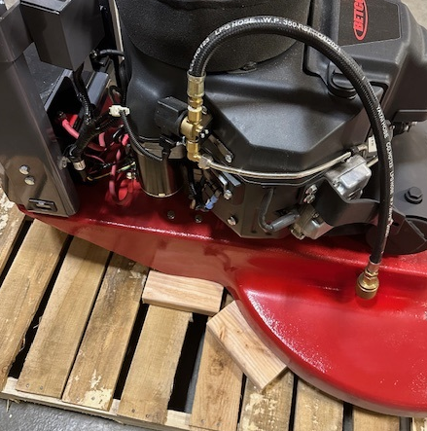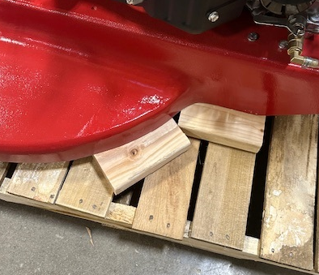

  - Use wood screws (88001) to attach another 2x4 block onto the pallet on the front of the machine. Then, place a poly band over the front end of the machine in the location shown.

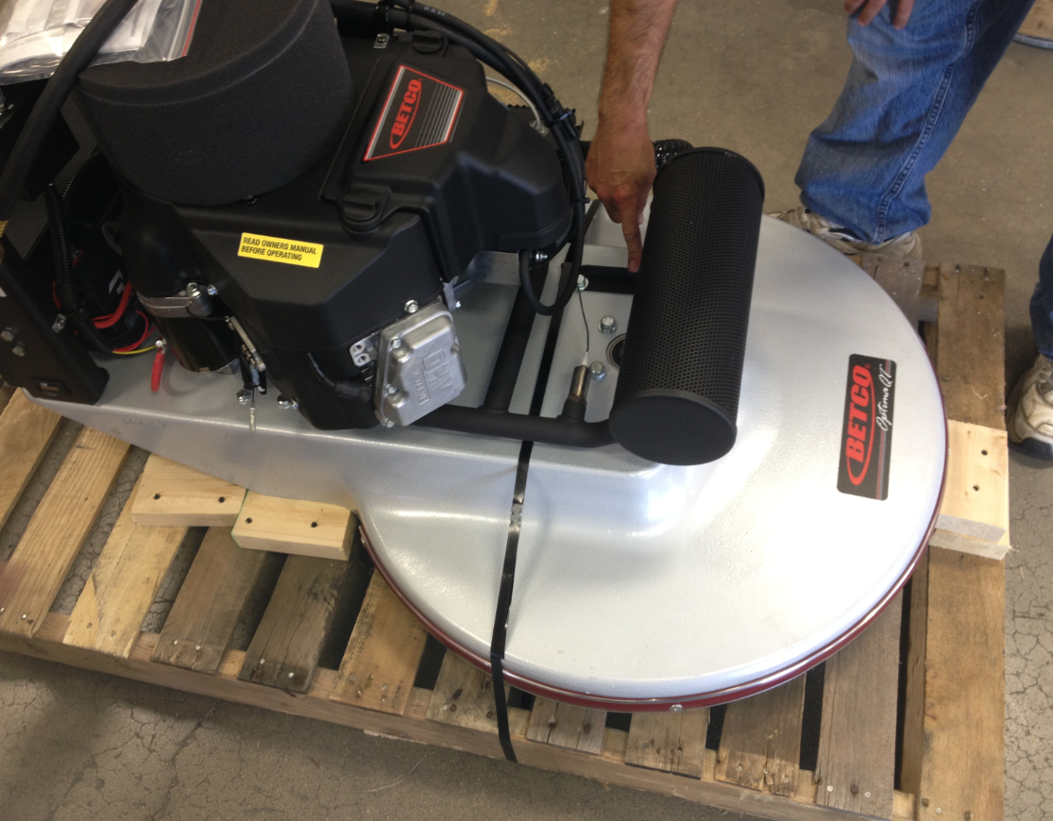

  - Place another band over the back side of the machine in the location shown. The banding should be run along the deck next to the solenoid. Verify that it is not over any electrical wires or other components, causing extra strain.

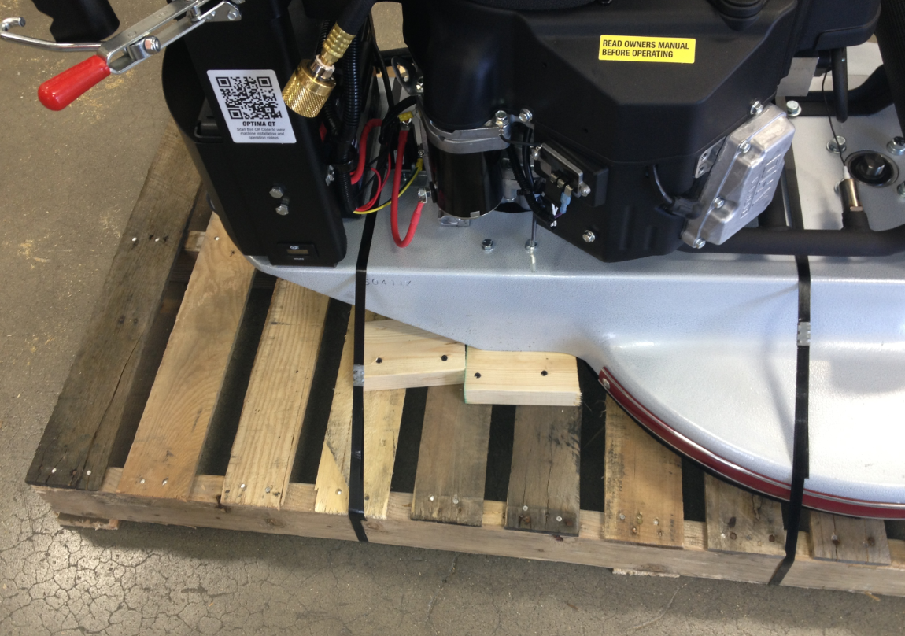
  - Take a propane tank (88550) and place a yellow label (11663) in the location shown.

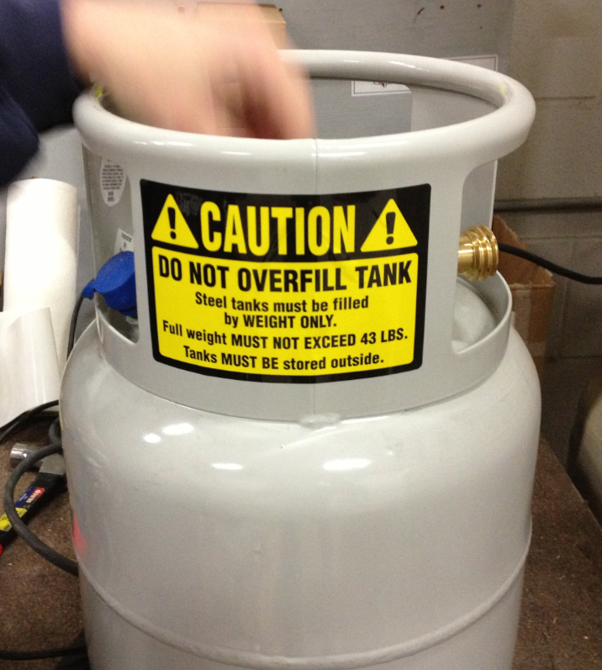

  - Place the tank onto the machine, strap it in place, and connect the fuel hose from the machine.

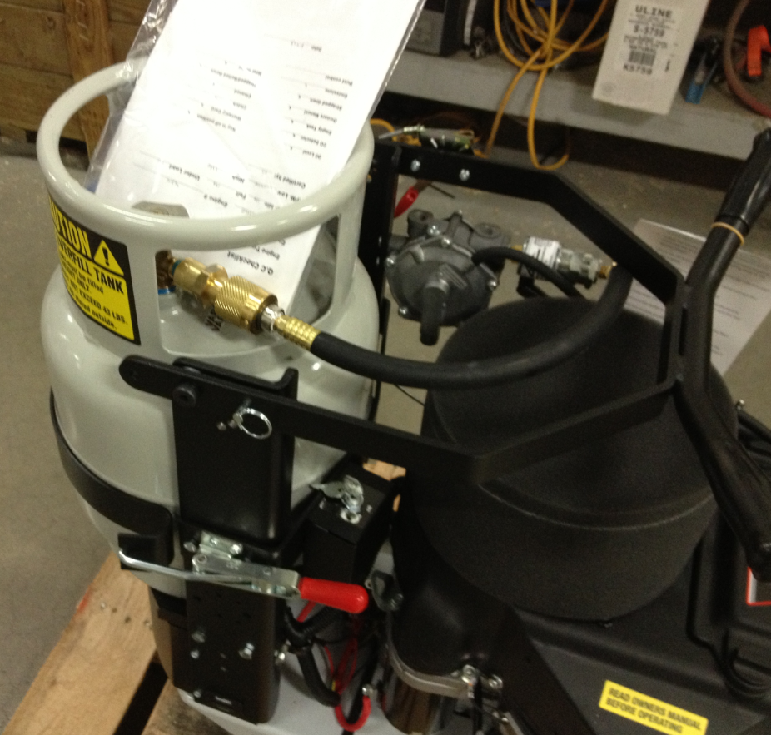
Connect to tank
Manual Packet
  - Place the manual packet into the top of the tank as shown above.
  - Assemble a shipping box (12664) and place the box over the machine. Verify that the edges of the box fit over the sides of the pallet.

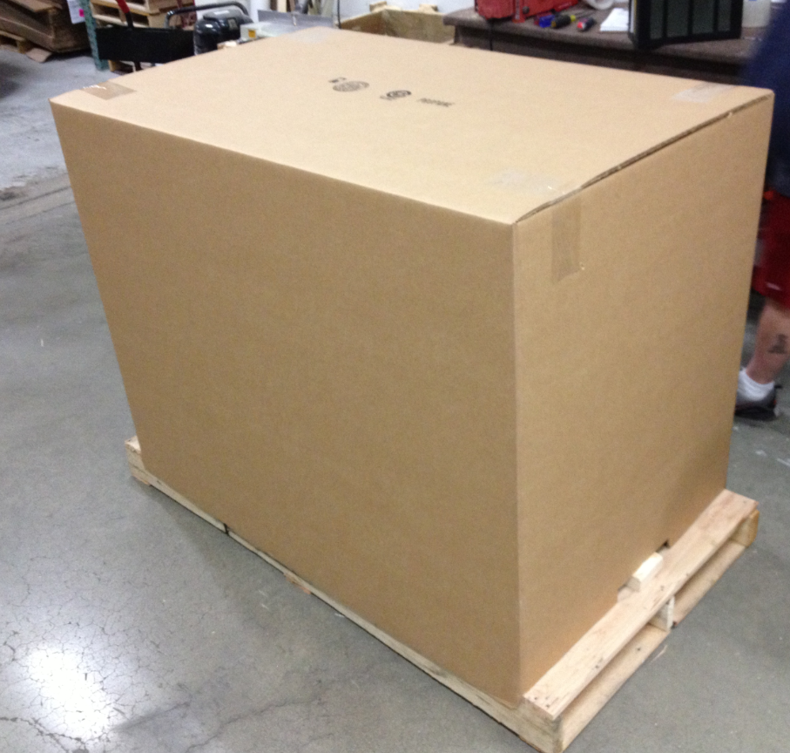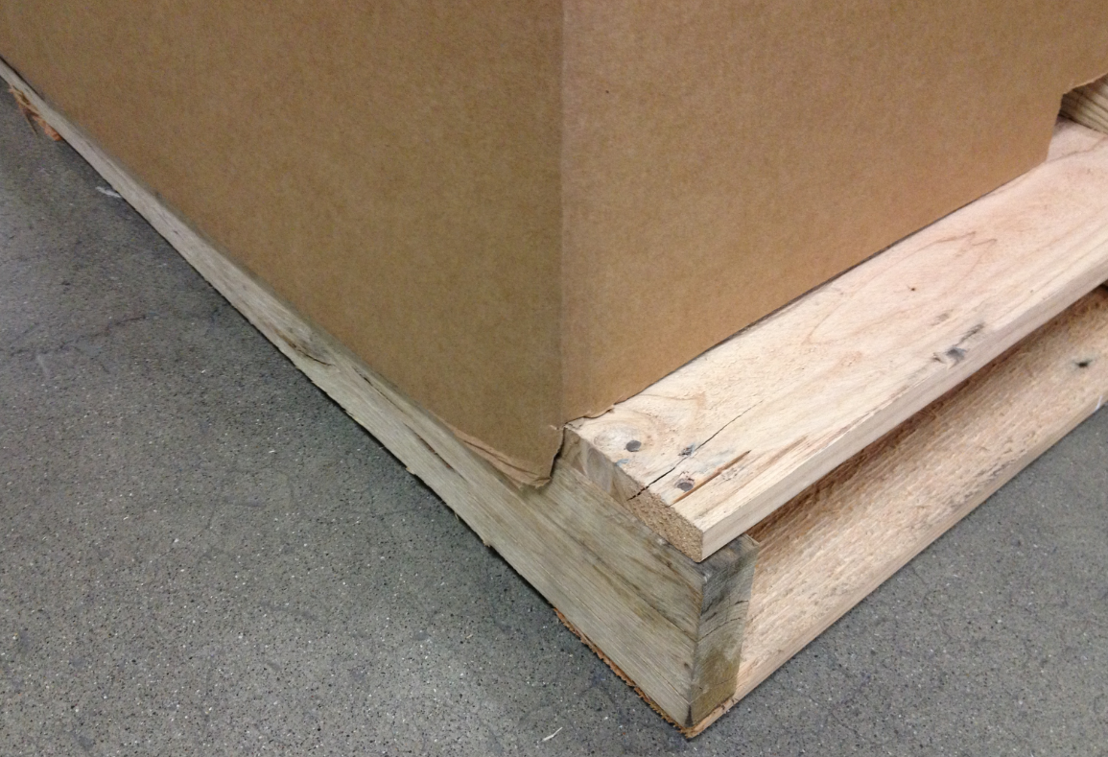

  - Place the barcode sticker onto adjacent corners of the machine. The inventory ID and the serial number will have a scannable barcode.

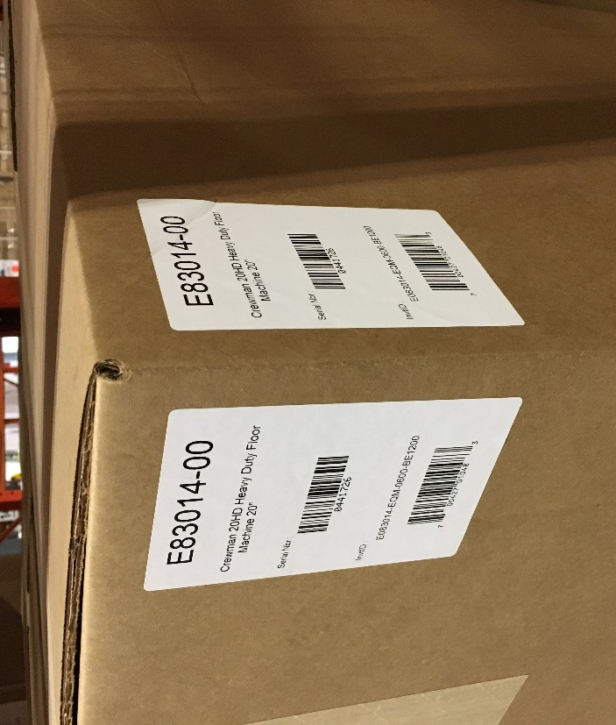

  - Place a “Do Not Top Load” label onto 2 opposite corners of the box.

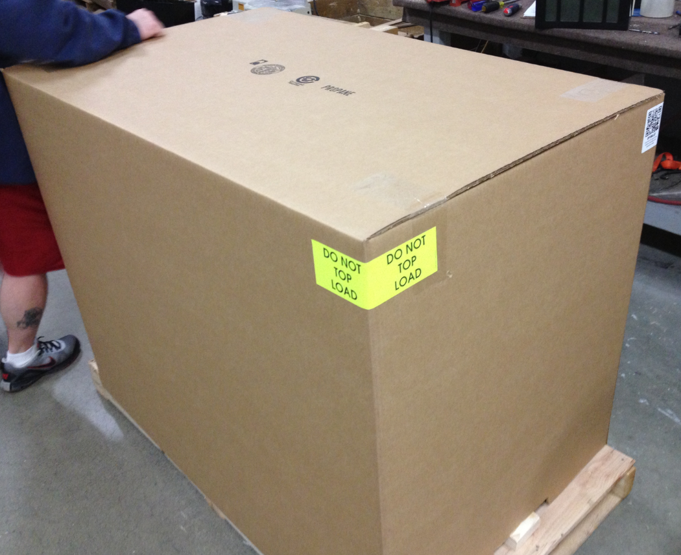

  - Place a UN3529 (RLB065A) sticker on the front of the box.
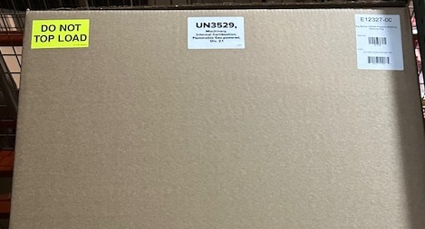
  - Staple the box to the pallet.

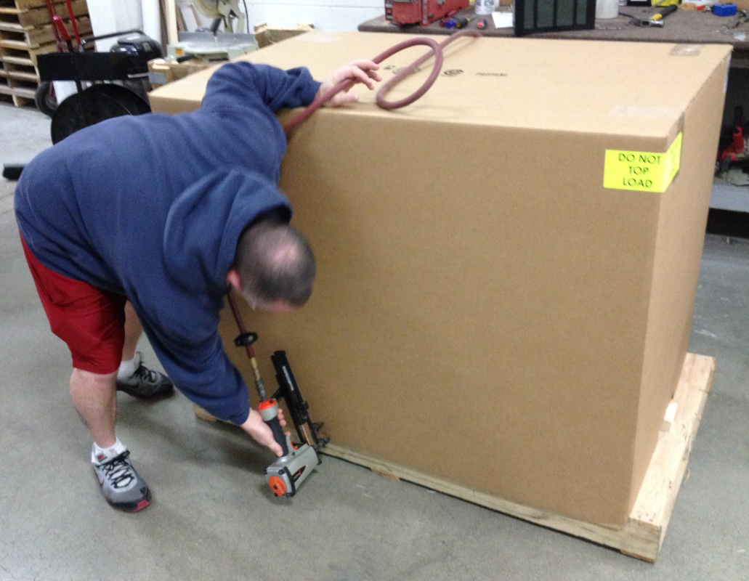
- References (optional section as needed)

- Training Guide

Functional Training Groups Requiring Training
Equipment Assembly Group

- SOP Change Control

Date of Change | Reason for Change
Rev 01 - 11/18/2013 | This is the first version of the S.O.P. hence there are no revisions to this document.
Rev 02 - 1/12/2018 | Remove unneeded box cutouts. Added Responsibilities Section
Rev 03 - 5/4/2018 | Updated for the Optima XR upgrade
Rev 04 - 3/15/2019 | Added “Xtended Run” hang tag
Rev 05 - 3/17/2025 | Updated instructions and combined with Dust Control version

Approvals

Submitter/Author Approval:__________________________________ Date:______________________

Management Approval:______________________________________ Date:______________________

QAU Approval:_____________________________________________ Date:______________________

